Electronic Grade Book
Project Management Plan
EEL5881, Fall, 2004

Modification history:
Version | Date | Who | Comment
v0.0 | 08/15/00 | G. H. Walton | Template
v1.0 | 10/11/04 | Eddy Sarita | First Draft
v1.1 | 10/24/04 | Eddy Sarita | Corrections

Team Name: Team 1
Team Members:
- Jaruwan Mesit, jmesit@cs.ucf.edu
- Chuang Huang, chuang@cs.ucf.edu
- Eddy Sarita, eddysar@hotmail.com
- JR Hollister, jhollister@yahoo.com

Contents of this Document
Project 0verview
Reference Documents
Applicable Standards
Project Team Organization
Deliverables
Software Life Cycle Process
Tools and Computing Environment
Configuration Management
Quality Assurance
Risk Management
Table of Work Packages, Time Estimates, and Assignments
PERT Chart
Technical Progress Metrics
Plan for tracking, control, and reporting of progress

Project 0verview
The project involves the implementation of an Electronic Grade book which allows an instructor to track each student's efforts for a semester-long class. It must allow for the entry of student information and display a class roster. The instructor must also be allowed to create categories of class work (i.e., homework, projects, tests, class participation, etc), and assign percentages to the category’s contribution to the final grade. Within each class work category, the instructor must be able to create assignments (and also assign percentages to those assignments) which will be tracked for each student. The instructor will be able to enter grade information for each student, and create a report on each student’s progress.

Applicable Standards
- Coding Standard: Java; Required documentation, naming conventions, etc... will be discussed at the start of implementation phase
- Document Standard:
  - Website will be updated once a week.
  - Normal font ranging from 10-16 in size.
  - Table of Contents, list of figures, etc..

Project Team Organization
All members of the group contribute equally to the project. Documentation and coding is divided equally among all the members.
- Members: Jaruwan Mesit, Chuang Huang, Eddy Sarita, JR Hollister.
- Project Manager: Jaruwan Mesit
- SQA: Chaung Huang, JR Hollister
- Programmers: Eddy Sarita Jaruwan Mesit, Chuang Huang, JR Hollister.
- Web Designer: JR Hollister.
- We will meet at least once a week. Documentation, files, and all project material will be posted online, therefore project can be updated online. Messages will be posted on an online forum/group indicating progress from each team member.

Deliverables
Artifact | Due Dates
Meeting Minutes | Once a week.
Individual Logs | Updated as needed.
Group Project Management Reports | N/A
ConOps | 10/12/04
Project Plan | 10/12/04
SRS | 10/12/04
High-Level Design | 11/02/04
Detailed Design | 11/02/04
Test Plan | 10/12/04
User's Manual | 11/30/04
Final Test Results | 11/30/04
Source, Executable, Build Instructions | 11/30/04
Project Legacy | 11/30/04

Software Life Cycle Process
Waterfall was chosen as our software process model due to the clients' emphasis on documentation, therefore making the project highly document driven. The clients’ requirements are clear and description is precise. This model is also a good choice must for easing future use and post maintainability.

Tools and Computing Environment
• Operating System: Windows XP
• Programming language: Java
• Compilers: Borland JBuilder X
• Library: Java Standard Libraries

Configuration Management
Each group member will be assigned a specific part of the code to work on. After each part of the code is compiled and tested on their own local copy, it will then be annexed to the full version located on the server. Comments are then added to the header of the code stating the changes that were made.

Quality Assurance
To ensure the highest possible quality of our project, documentation along with continuous testing will be done throughout the project implementation. This approach minimizes the amount of bugs in our end result.

Risk Management
- Time Management: Time is defined, therefore efficiency and quality is our goal for this project. We will therefore follow our defined schedule.

Table of Work Packages, Time Estimates, and Assignments
Work package | Estimated Time | Responsibility | Assignment
Concepts of Operation | 3 hrs, 10/10/04 | Team | Formalize basic understanding of the project in general. Complete ConOp Template
Software Requirement Specification | 4 hrs, 10/10/04 | Team | Describe the functionalities required for the project. Complete SRS Template
Project Management Plan | 4 hrs, 10/10/04 | Team | Layout for Team Organization, Software Model, Time management and project management. Complete PMP template
High Level Design | 2 hrs, 10/10/04 | Team | Layout of components of our system and the interfaces. Complete HLD template.
Detailed Design | TBA | Team | TBA
Test Plan | TBA | Team | TBA
Implementation | TBA | Team | TBA
Testing | TBA | Team | TBA
Final Documentation | TBA | Team | TBA

PERT Chart

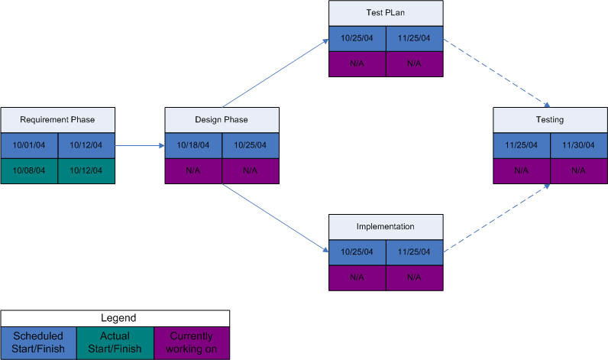

Technical Progress Metrics
- For Requirement phase, the total number of requirements matrix is used
- For OO Analysis and design, UML diagrams will be used.
- For detailed design and code, we will use matrices to count packages, classes, methods. Also using execution speed matrix to analyze the code efficiency.

Plan for tracking, control, and reporting of progress
- At a minimum, each team member will post the following information weekly: individual time and activity log, individual status information, and individual issues and problems
- Each week, the team members will: read and analyze the logs; examine the technical content of the work done to date; examine the technical progress metrics; consider the QA results; reassess the potential project risks; and take corrective action if necessary.
- The team will issue a Project Management Report on the schedule as indicated in the deliverables section above.
- The Project Management Report will be generated every two weeks and will include the following information:
  - 1 sentence description of overall status
  - 1 or 2 sentence of any planned changes to the project plan
  - graph of planned vs. actual time
  - graph of planned vs. actual for each technical progress metric
  - updated PERT chart.
- The Project Management Report will be evaluated by all team members.
- The team members will then decide together if any corrective action that is necessary for the project or how the pace of the project should be altered.

Template created by G. Walton (GWalton@mail.ucf.edu) on Aug 30, 1999 and last updated Aug 15, 2000
This page last modified by Eddy Sarita on 10/24/04

